NLA User Management Interface (UMI)

User Guide

Contents

Overview 2
Requesting a new organisation 2
Scenario 1 – org already exists 2
Scenario 2 – org and user already exist 3
Scenario 3 – too many org name matches 3
Scenario 4 – org does not already exist 4
Managing (add / amend) eClips users 4
Adding / Removing Users 4
Forgotten passwords 5
Restoring a deleted user 5

Overview

The NLA User Management Interface (UMI) can be found here: www.nla-eclips.com/manage and is accessible from any computer with internet access.

If you already have a username and password to view eClips cuttings, you will be able use the same login credentials to access the UMI.

If you do not have a UMI and/or eClips username and password, please email clientservices@nla.co.uk and request one.

Requesting a new organisation

Once you have logged into the UMI, you can request a new client organisation by navigating to the ‘Request new organisation’ tab.

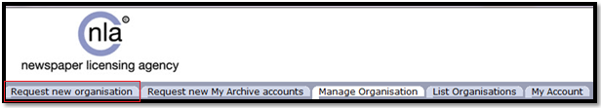
Before submitting your new organisation request, please ensure that you complete all of the required fields, including: Organisation Name, Address, Contact Name, Contact Telephone Number, Default Administrator details and No. of eClips Users etc.
Once you have completed the new organisation request form, please select ‘Create’ at the bottom of the form.

Scenario 1 – org already exists

If the organisation you have requested already exists on the UMI, you will be presented with the option to link your organisation to the requested client organisation.

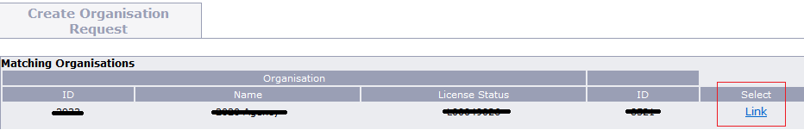

The default user will be registered as soon as you link your organisation to the requested client organisation.

Scenario 2 – org and user already exist

If the organisation and Default Administrator already exist on the UMI, you will be presented with the option to link your organisation to the requested client organisation.

You will also be given the eClips login details for the existing user you requested.

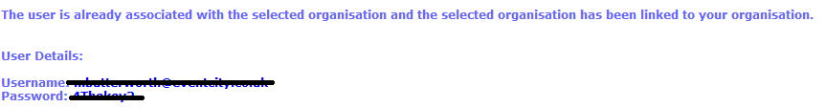

Scenario 3 – too many org name matches

If you register a new organisation and are presented with the error message, below please either go back to the form and enter more details or a different Organisation name. Alternatively click ‘No matches found’ to send your request to the NLA Client Services and Licensing teams for approval.

Scenario 4 – org does not already exist

If you register a new organisation that does not already exist on the UMI, a new organisation request will be sent to the NLA Client Services and Licensing teams for approval.

Once the new organisation request has been approved, the NLA Client Services Team will notify you.

Managing (add / amend) eClips users

Once you have logged into the UMI, you can view the client organisations linked to your organisation by navigating to the ‘List Organisations’ tab.

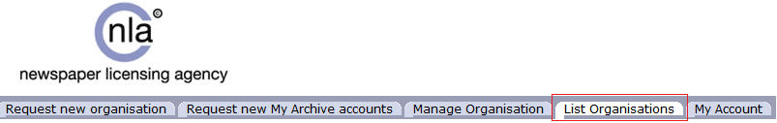

Once you have found the organisation you are looking for, select the organisation name in order to see a list of users registered under that organisation.
Please note that when your organisation is initially linked to a new organisation, you will only be able to see the users that your organisation has set up. If you try to add a username that already exists the system will let you know that users current login details and add them to your user list.

Adding / Removing Users

Once you have selected a client organisation you can then add or delete users and amend passwords.
To add a new user, select ‘Add New User(s)’ and complete the relevant fields.
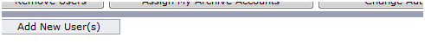
To delete a user, select the user(s) you want to delete and choose ‘Remove Users’.
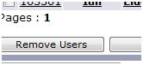

Forgotten passwords

To change a clients’ password select ‘change password’ and complete the relevant fields.

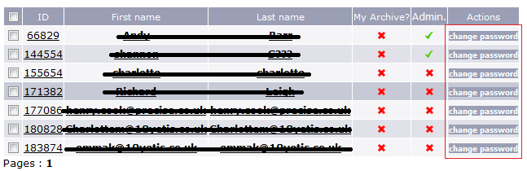
Please note that passwords must contain at least 5 Characters.

Restoring a deleted user

To find and restore a deleted user, login to the UMI as the client organisation’s administrator i.e. not your own admin login details and select the ‘Search’ option towards the top of the UMI. (NB: you can leave the search field blank).

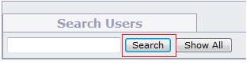
Then find the user you wish to restore and choose ‘Restore User’
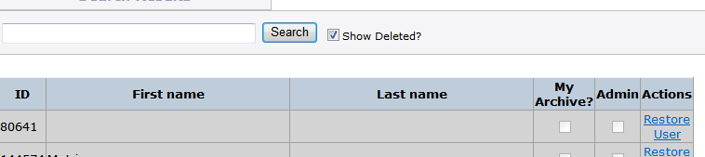
If you do not know who the administrator is for an organisation, you can either create one or contact the NLA Client Services Team.

